NAME: Elvia Gisella Adair
DATE: January 16, 2026
MODULE 1.3: Assignment: Building a Web Page Exercise, Part 1

ASSIGNMENT: BUILDING A WEB PAGE EXERCISE, PART 1
- Create a new directory under your local csd-340 folder (repository) and name it module-1
- Create a new HTML document in a text editor and name it .html and place it in the module-1 directory
- Using the below starter code, create a basic HTML page and add the code to your .html document
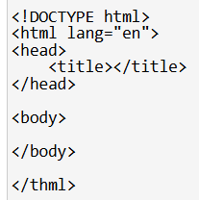
- Visit the World Wide Web Consortium (W3C) website and validate the markup you wrote using their HTML validator: Hint: Select the “Validate by Direct Input” link and paste the markup you wrote into the input field.
- Take a screenshot of the validators' results (there should be one or more errors)
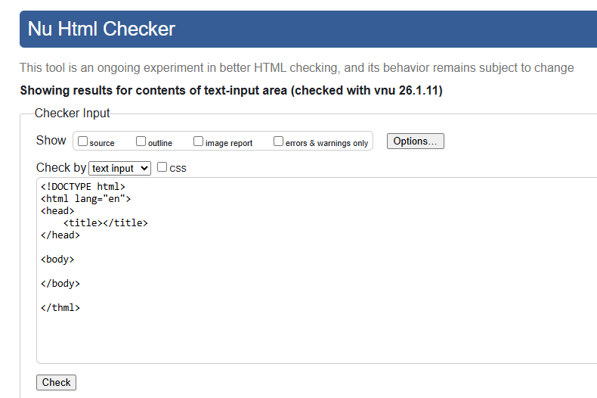
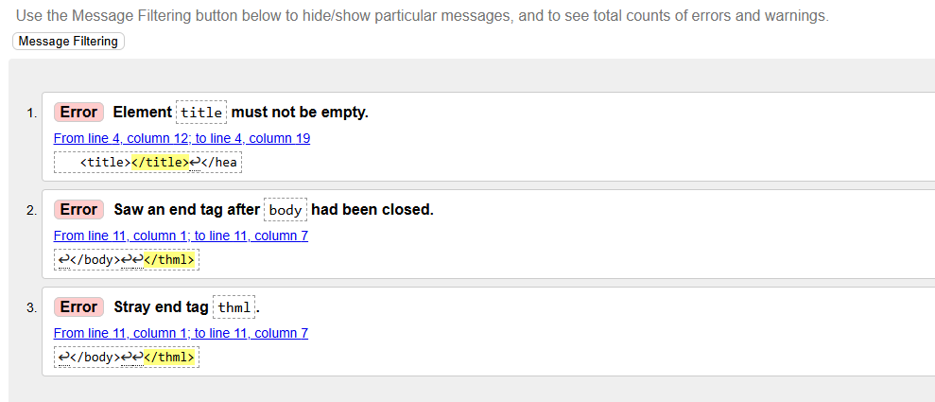
- Correct the identified errors
- Re-validate the HTML code:
  - Hint: Paste the updated HTML code into the validator again
- Take a screenshot of the updated results (this time, there should be 0 errors)

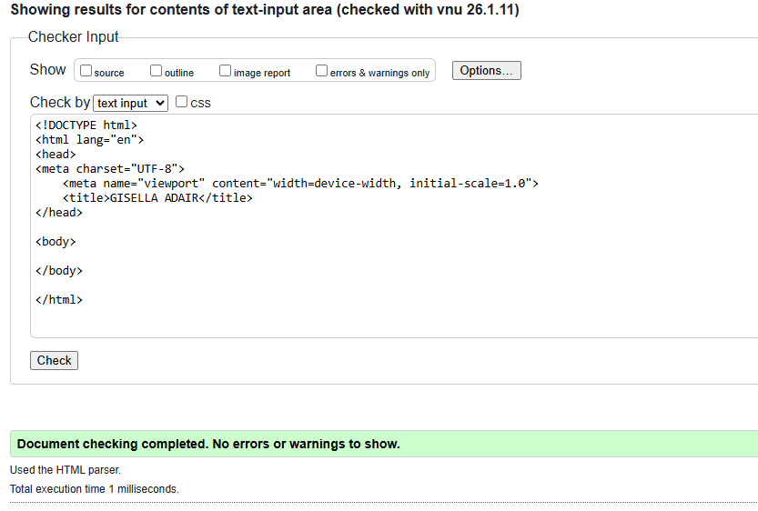
- Add a single <h1> element underneath the <body> element with the following text: “Assignment 1.3 - Building a Web Page Exercise, Part 1”
- Add a sentence under the <h1> that describes your location and today’s weather. Include the degree symbol (use HTML or keyboard input)
- Update the document's title to “CSD 340 Web Development with HTML and CSS”
- Hint:Update the text in the <title> element inside the <head>
- Re-validate the HTML code
- Take a screenshot of the updated results (this time, there should be 0 errors)

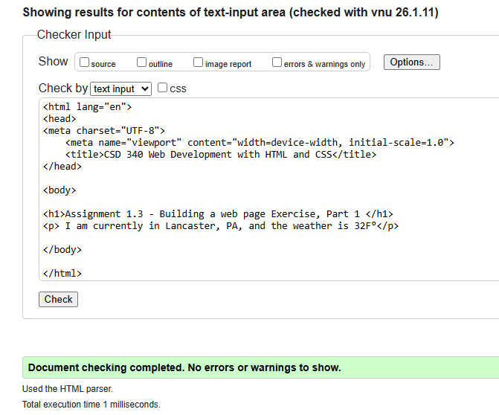
- Open the file in your computer's default browser and take a screenshot of the web page
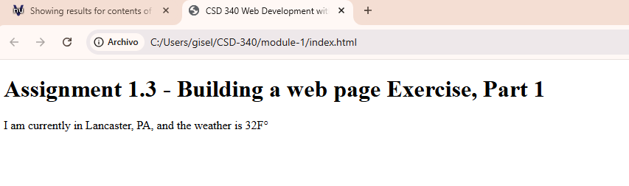
- Combine all images into a single Word document and include your name, date, and assignment number.

